|  |  |  |
| --- | --- | --- |
| Memory | | |
| Input | Process | Output |
| Select the row and column | COMPARE the row and column to see if they match | To see if they match or not  Variables |

|  |  |  |
| --- | --- | --- |
| Composite | | |
| Input | Process | Output |
| Find if it is prime or not | Check if the number is devisable by any other number besides itself and 1 , if it does it equals prime  Then check the numbers and find the ones that do go into the number whole then out put those | Show weather the number is prime  And if it isn’t prime show all the factors for it |

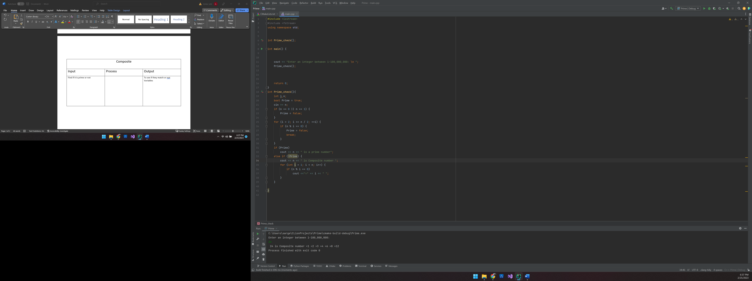

C:\Users\sarga\CLionProjects\Prime\cmake-build-debug\Prime.exe

Enter an integer between 1-100,000,000:

24

24 is Composite number 1 2 3 4 6 8 12

Process finished with exit code 0

|  |  |  |
| --- | --- | --- |
| Board | | |
| Input | Process | Output |
| Make a random number of places | Make a 20 x20 array  Add in random numbers highest is 8  Create a peak system | 20x 20 board  Show the peak system |

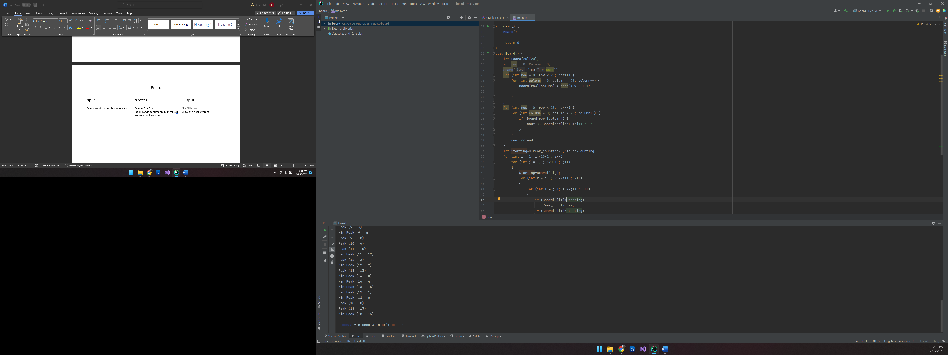

7 3 4 6 7 8 8 3 1 6 1 4 7 5 1 4 4 6 5 8

4 8 4 7 4 7 8 4 5 2 8 1 5 3 4 5 7 5 3 1

4 1 2 8 2 1 6 6 4 1 4 3 2 3 6 7 2 2 1 8

7 1 5 1 1 4 5 6 5 7 7 5 7 6 6 7 5 5 6 8

5 1 7 2 2 6 6 1 3 3 8 3 5 3 1 6 2 5 5 6

2 6 4 7 1 5 3 8 8 8 8 1 8 5 6 6 5 3 2 4

8 2 5 4 7 8 4 6 1 6 4 7 4 2 2 6 2 6 2 4

4 1 5 2 5 5 1 7 2 1 4 1 7 7 8 4 6 8 6 1

5 7 4 1 5 4 8 3 2 2 2 2 8 2 5 2 2 1 7 4

1 8 2 8 3 3 1 2 1 4 6 1 6 8 3 4 5 2 8 5

2 7 5 2 4 2 8 2 1 1 1 6 2 8 4 8 1 4 7 7

1 2 5 3 4 1 2 7 2 6 8 5 1 6 1 6 8 1 6 1

1 5 7 4 6 1 4 1 3 3 4 3 4 4 3 1 8 2 1 2

6 6 1 2 7 8 8 4 5 7 7 8 2 5 1 7 4 3 1 5

8 1 6 5 4 8 8 3 1 4 8 6 1 4 3 5 5 3 8 4

2 4 2 7 5 2 7 6 5 6 2 1 8 4 6 6 8 8 4 1

7 5 7 3 1 6 6 6 2 1 1 7 8 8 8 5 1 2 1 2

8 2 8 8 4 6 3 5 1 3 7 2 3 6 5 8 8 6 1 4

6 8 5 5 6 3 1 3 7 6 6 2 5 7 3 7 3 6 7 3

6 8 8 6 4 8 4 6 6 3 5 7 2 2 2 5 4 6 5 8

Peak (1 , 1)

Peak (1 , 10)

Peak (2 , 3)

Min Peak (2 , 9)

Peak (3 , 12)

Min Peak (4 , 7)

Min Peak (4 , 14)

Min Peak (4 , 16)

Min Peak (5 , 4)

Min Peak (5 , 11)

Peak (5 , 12)

Peak (6 , 5)

Min Peak (6 , 16)

Min Peak (7 , 1)

Min Peak (7 , 6)

Min Peak (7 , 11)

Peak (7 , 14)

Peak (7 , 17)

Min Peak (8 , 3)

Peak (8 , 6)

Min Peak (8 , 13)

Min Peak (8 , 17)

Peak (9 , 1)

Peak (9 , 3)

Min Peak (9 , 6)

Peak (9 , 18)

Peak (10 , 6)

Peak (11 , 10)

Min Peak (11 , 12)

Peak (12 , 2)

Min Peak (12 , 7)

Peak (13 , 13)

Min Peak (14 , 8)

Min Peak (16 , 4)

Min Peak (16 , 16)

Min Peak (17 , 1)

Min Peak (18 , 6)

Peak (18 , 8)

Peak (18 , 13)

Min Peak (18 , 16)

Process finished with exit code 0